Setup document

Course: ProP

Group: 31

Dimitar Parpulov - 3207358

Diqin Yang - 3324087

Dongdong Ke - 3338207

Phat Tran - 3335968

# Table of Content

**Agreements - made with the client** **3**

**Process** **4**

**Functional Requirements** **5**

**GUI** **6**

**Website Wireframe** **7**

**ERD** **8**

|  |  |  |  |
| --- | --- | --- | --- |
| Version | Version date | Changes made | Author |
| 1 | 05.03.2018 | Added all sections, filling the information for each section | Dimitar Parpulov, Diqin Yang, Dongdong Ke, Phat Tran |
|  |  |  |  |
|  |  |  |  |

# Agreements - made with the client

We agreed to deliver the following software for the event organised by our client - Mr. Mikaeil

Applications:

- An application to be used at the entrance of the event

- An application to be used at the entrance of the campsite

- An application to be used at the shops

- An application to be used at the loaning stands

- An application to be used when a visitor leaves the event

- An application to be used when a visitor leaves the campsite

- An application for the organization to inspect the status of the event (dashboard)

Others:

- A website

- A database

- A presentation about the project

Extra features that can be added:

* Give access to the event for only a day or two for a reduced price
* Newsletter

# 

# Process

**Use cases**

Preconditions:

The following preconditions are valid for every use-case mentioned under:

1. The application is running.

2. The user is logged in with their unique username and password.

If there is a precondition unique for an application, it will be mentioned in the specific use-case.

Exceptions:

The following exceptions are valid for every use-case mentioned under:

1. Connection lost

**Check-In**

User task: Check-in

Functional requirements:

1. User scans the unique QR code

**Success scenario:**

1. QR code gets scanned.
2. System requests information from the database
3. Database returns information about the user
4. Form shows that the entry is successful and if he has access to the campsite

**Failure scenario:**

1. No user found in the database
2. Customer is send to the information desk

# Functional Requirements

**MoSCoW table**

*Allapplications will be connected to the database

*All applications will have the option to refresh their connection to the database.

|  |  |  |  |  |
| --- | --- | --- | --- | --- |
| Requirements | Must | Should | Could | Won’t |
| Entrance festival application |  |  |  |  |
| Is entry successful? | x |  |  |  |
| Campsite access? | x |  |  |  |
| User info transferred to RFID bracelet | x |  |  |  |
| For which days do you have access? |  |  | x |  |
| Exit festival application |  |  |  |  |
| Is exit successful? | x |  |  |  |
| RFID bracelet returned? |  | x |  |  |
| Loaned items returned? | x |  |  |  |
| Campsite spot is freed? |  |  | x |  |
| Entrance camping site application |  |  |  |  |
| Is entry successful? | x |  |  |  |
| Which camping spot? | x |  |  |  |
| Is the spot payed? | x |  |  |  |
| Pay the camping spot | x |  |  |  |
| Show roommates info |  |  | x |  |
| Exit camping site application |  |  |  |  |
| Is exit successful? | x |  |  |  |
| Food and Drinks shops application |  |  |  |  |
| Employee check in |  | x |  |  |
| Select multiple foods and drinks | x |  |  |  |
| Remove an item from the order | x |  |  |  |
| Order preview | x |  |  |  |
| Total cost | x |  |  |  |
| Buying of items is successful? | x |  |  |  |
| Decrease the balance of the user | x |  |  |  |
| Loaning stands application |  |  |  |  |
| Employee check in |  | x |  |  |
| Select multiple items | x |  |  |  |
| Remove an item from the order | x |  |  |  |
| Order preview | x |  |  |  |
| Total cost | x |  |  |  |
| Loaning successful? | x |  |  |  |
| Decrease the balance of the user | x |  |  |  |
| Return item | x |  |  |  |
| Overview application |  |  |  |  |
| Access only to Admin users |  | x |  |  |
| Total current visitors | x |  |  |  |
| Bank log | x |  |  |  |
| Overview of shops information | x |  |  |  |
| Update database (delivery) | x |  |  |  |
| Website |  |  |  |  |
| Check the information about the Event | x |  |  |  |
| Contact with the Organizer. | x |  |  |  |
| Buy tickets and reserve camping spots. | x |  |  |  |
| Refund a ticket and camping spots. |  |  |  | x |
| Register an account for the website. | x |  |  |  |
| Re-book the tickets and camping spots |  |  |  | x |
| Log in with Facebook or Twitter |  |  | x |  |
| Change the date of the tickets |  | x |  |  |
| Newsletter |  |  | x |  |
| Database |  |  |  |  |
| Holds information about each person | x |  |  |  |
| Holds information about loaned items | x |  |  |  |
| Holds information about purchases made | x |  |  |  |
| Hold information about the tickets bought | x |  |  |  |
| Hold information received from the applications | x |  |  |  |

# GUI

-Application of Festival and Camping

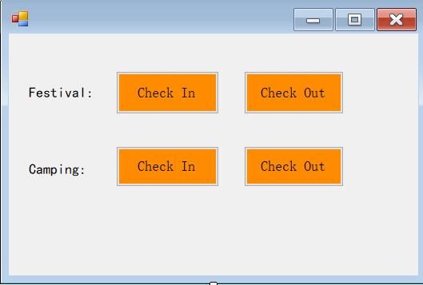

-Check In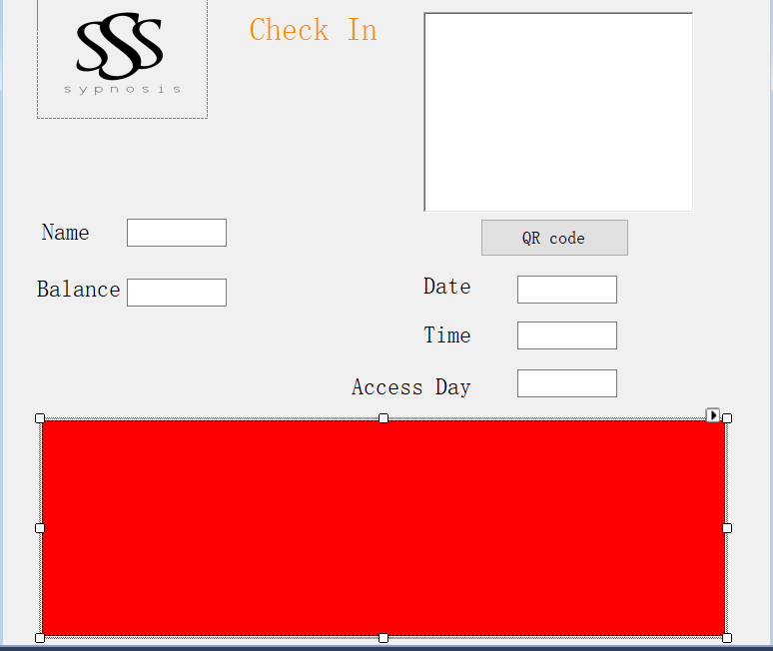

-Check Out

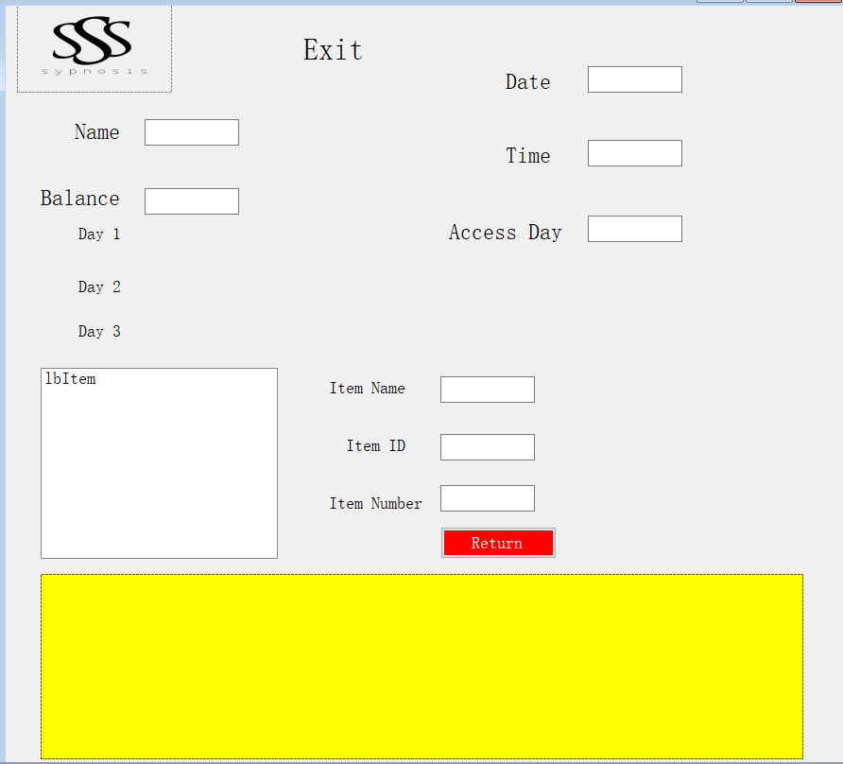

-Camping Entrance

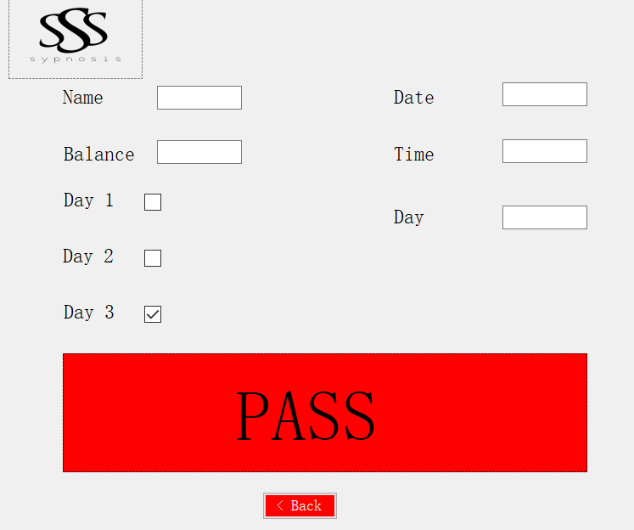

-Overview shops and loaning

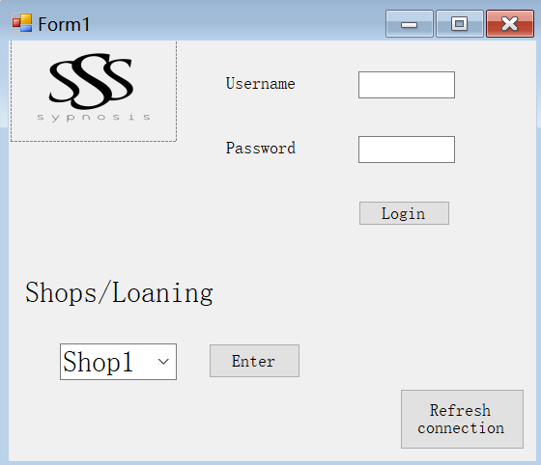

-Shops

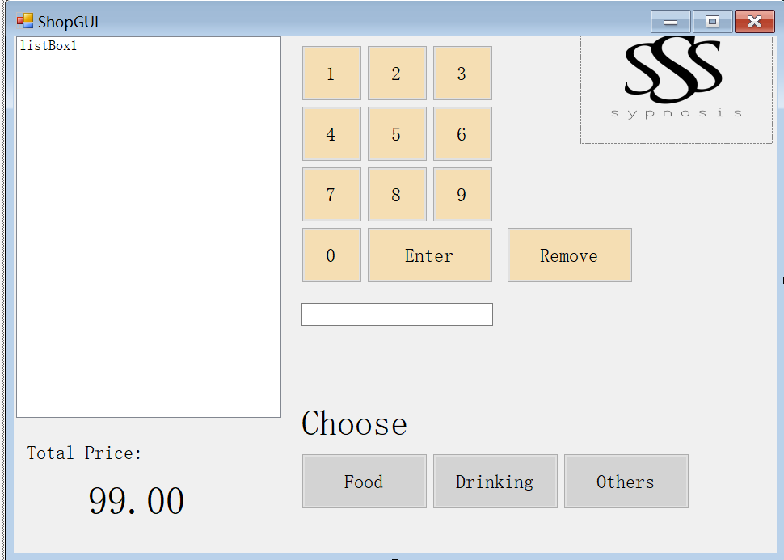

-Shops(Food)

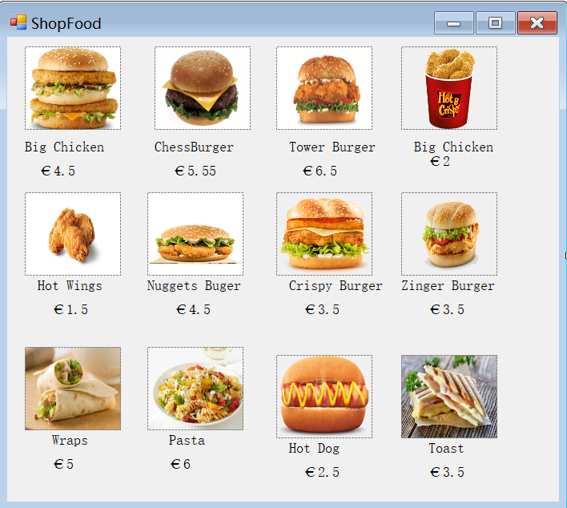

# Website Wireframe and Visual Design

The website will be user-friendly. All the information about the event, the onsite camping and everything related to the tickets will be easy to find. People will be able to see the line-up and schedule of the event. Information such as tickets bought, access to the event and the camping area, money spent will be available in the account information of each user.

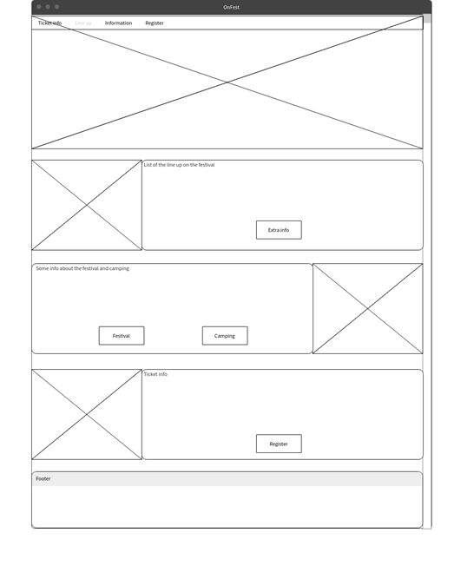

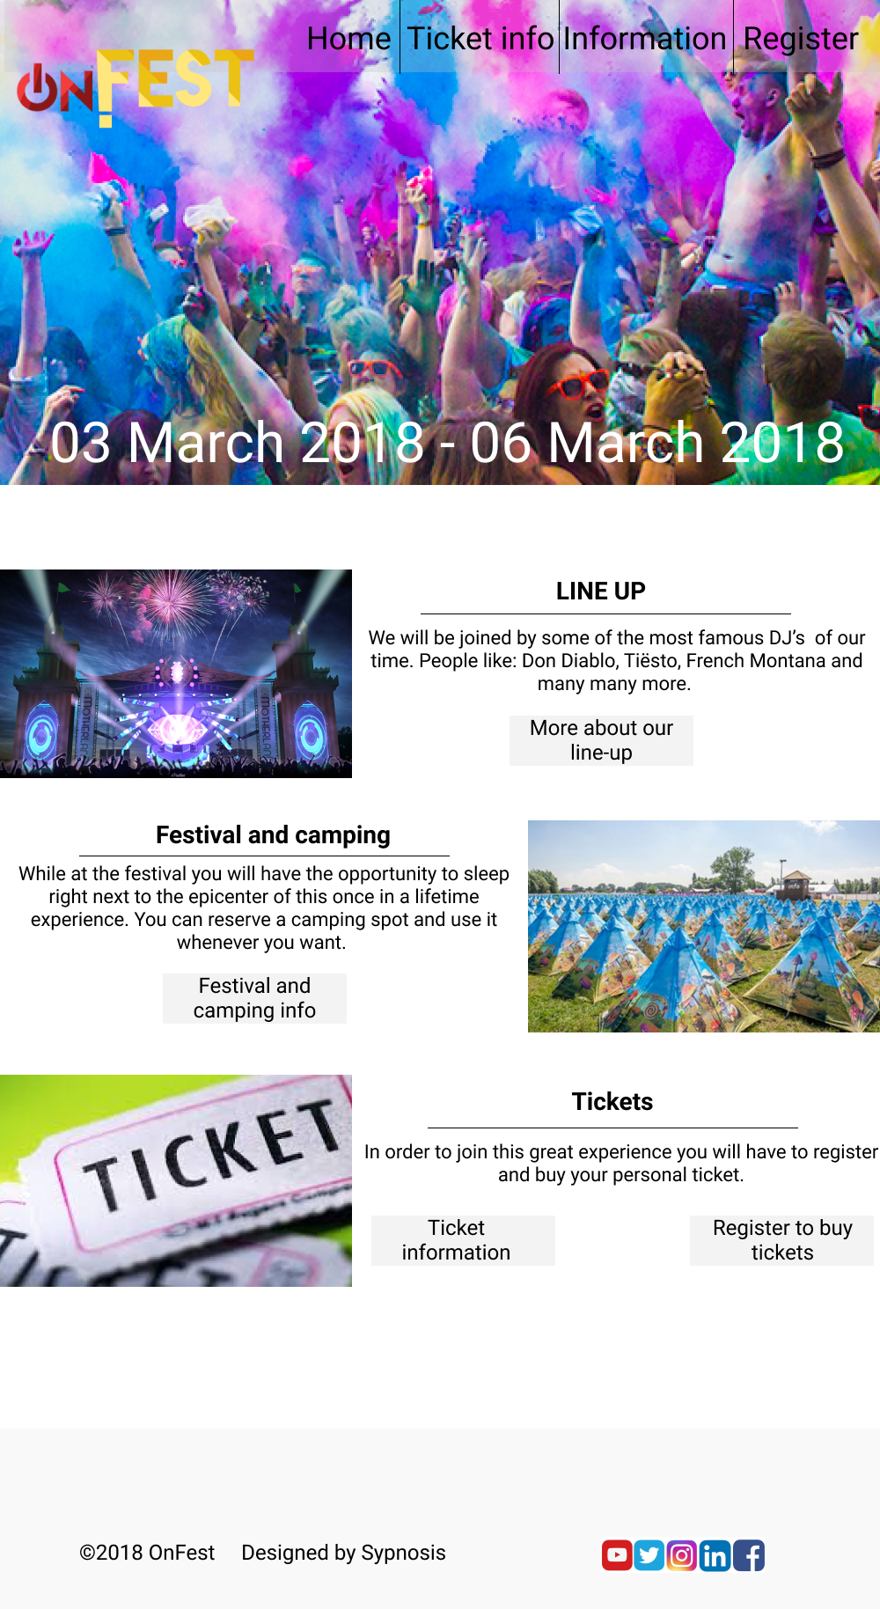

# 

# 

# 

# 

# 

# 

# ERD

Visitors -

CampingSpot -

Venue-

Stage-

Transaction-

Account-

Nationality-

Ticket-

Festival-

Performance-

Artist-

